

Foc Assignment

1. Draw Block Diagram of digital computer? Ans…

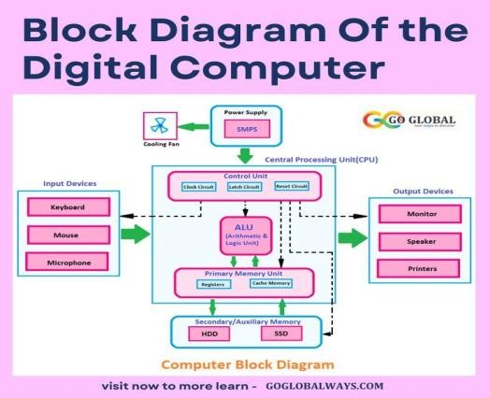

1. What is the full form of computer?

C - Common O - Operating M - Machine P - Particular U - Used for

T - Technological and E - Educational

R – Research

1. Discuss at least 2 Input devices and 2 Output devices?

Ans. Input devices are controlled by the users. Output devices are controlled by computers. Mouse, keyboards etc., are input device examples. And Monitors, printers etc., are examples of output devices. An input/output

device, known as an IO device, is any hardware that allows a human operator or other system to interface with a computer

Name – KARAN CHAUDHARY

Involvement no – 20230047